# Project Development Phase Model Performance Test

|  |  |
| --- | --- |
| Date | 25 june 2026 |
| Team ID | LTVIP2025TMID46306 |
| Project Name | HematoVision: Advanced Blood Cell Classification Using Transfer Learning |

## Model Performance Testing:

Project team shall fill the following information in model performance testing template.

|  |  |  |
| --- | --- | --- |
| **S.No.** | **Parameter** | **Values** |
| 1. | Metrics | Classification Model: transfer learning , Classification Re |

Screenshot: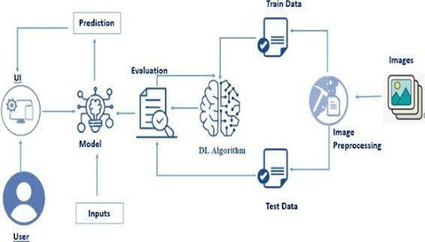

**Project Development Phase**

**Model Performance Test**

|  |  |
| --- | --- |
| **Date** | 10 February 2025 |
| **Team ID** | LTVIP2025TMID46306 |
| **Project Name** | HematoVision: Advanced Blood Cell Classification Using Transfer Learning |
| **Maximum Marks** | 10 Marks |

**Model Performance Testing:**

Project team shall fill the following information in model performance testing template.

|  |  |  |  |
| --- | --- | --- | --- |
| **S.NO** | **Parameter** | **Values** | **Screenshot** |
| 1. | Metrics | **Regression Model:**  MAE-,MSE-,RMSE-,R2 score-  **Classification Model:**  Confusion Matrix-,Accuray Score- & Classification Report- |  |
| 2. | Turn the Model | Hyperparameter Tuning-  Validation Method- |  |

